Installing the client
- Download the client from : CoreFTP Website
- Accept all the defaults (ex. Next, Next, Close)
- Most people select “No” for the ASCII editor
- License the software:
  - Start up CoreFTP Pro
  - Go to Help
  - Register
  - Copy the string from Media:CoreFTP_License.doc to the textbox
  - Hit OK & Restart CoreFTP

Configuring the client
Site Manager, see: Figure 1
- Go to Sites -> Site Manager
- Give the site a name
- Enter the Host/IP/URL:
  - Hqnvhwy01.Domain Name (download from HQ)
  - Hqnvhwy02. Domain Name (download from HQ-Secondary site)
  - Hknvhwy01. Domain Name (download from Hong Kong or APAC sites)
  - Tainvhwy01. Domain Name (download from Taiwan)
  - Uknvhwy01. Domain Name (download from UK or EU sites)
  - Punvhwy01. Domain Name (download from BG, HYD or Pune)
- Username is formatted as:
  - Domain Name\%username%
- Port:
  - 21
- Connection:
  - AUTH TLS
Figure 1
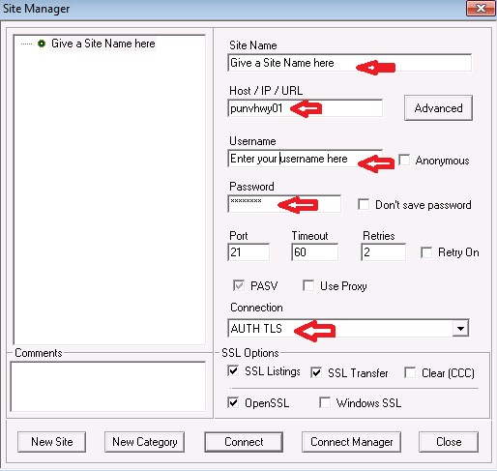

Options, see: Figure 2
IMPORTANT!: Must be set to accelerate download!
- Go to View -> Options -> Connections
- Change the following:
  - Connection Types
    - Multiple for each Transfer
    - Max conns per host: 20
    - Total max connections: 20
    - Mult Max: 5
  - Fast Connections Checked
Figure 2
