Step 1 | Copy the company Number from excel (Cell P3) | 
Step 2 | Click on Search button in webpage
Step 3 | Copy the store Number from excel  Click on search button (O3) | 
Step 4 | Pick date from excel and paste in webpage (Cell G3) | 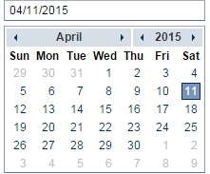
Step 5 | Update account and paste it in account (Cell I3 right 4 digits) | 
Step 6 | Select Each link in the page | 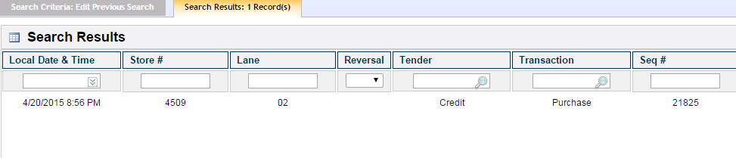
Step 7 | Once the page is opened take screen print of the page and save to a folder

