- I have to double click on “RANA” in this window so as to launch it. But AutoIt window info tool takes it as a grid. Below is the info from AutoIT Window Info tool. Please guide me.
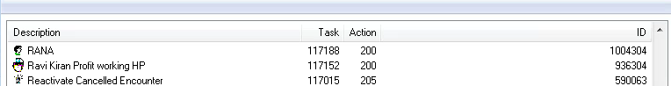

Info from AutoIT window Info tool is in this image attached:
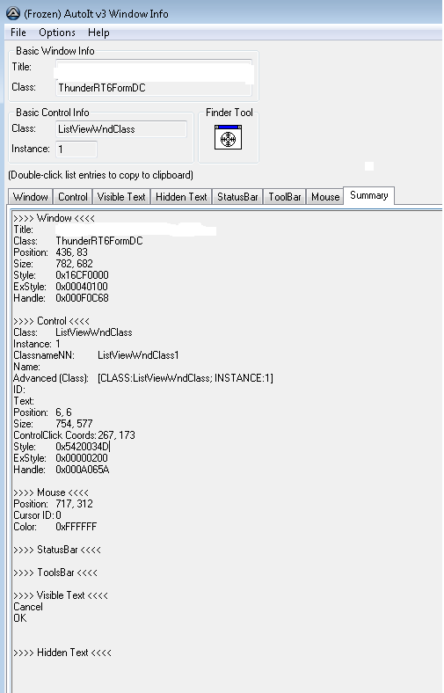

- In this below image, a text box is in the grid. How can I enter text in this textbox and click somewhere in this textbox based on text present?
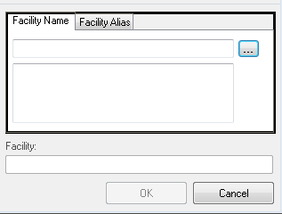

Black outline is what is recognized by AutoIT. How should I proceed with that. Please guide me on this also.

