These are the screen shots

 This how the link looked in the word document before I run the code. (the find and replace)
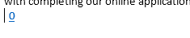 This is what it looked like after running the code. It wipes out the text and does not change the link.
 This is before I run the code....
and this is after I run the code.

