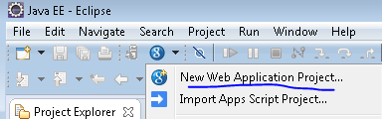
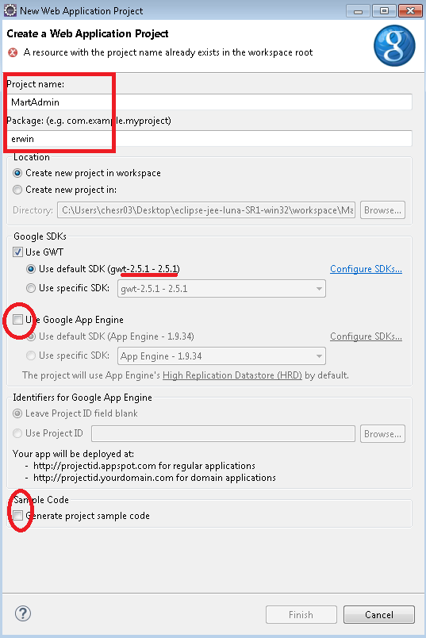
Drag and drop below files after default next next of above screen.
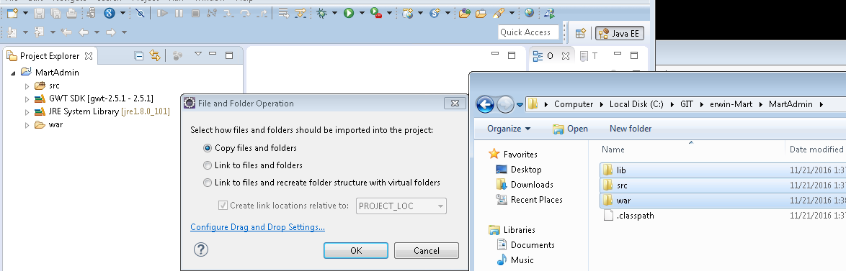

Let Building complete shown in progress on right edge.
Refresh
Right click build path configure
And add the external 3 jar files and keep 22 name in the order first.
Refresh
Red cross should be gone, yellow can be??
G gwt compile project
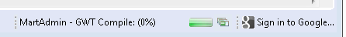
Refresh after above compilation is Successful.
