When script is interrupted and reopened to continue where we left

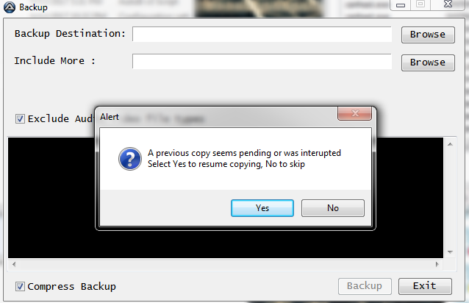

After clicking YES :
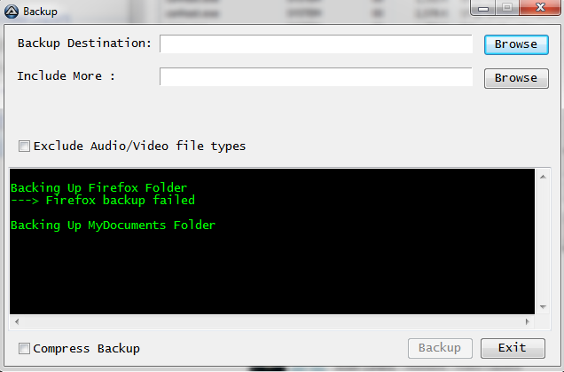

When I see in current.ini file
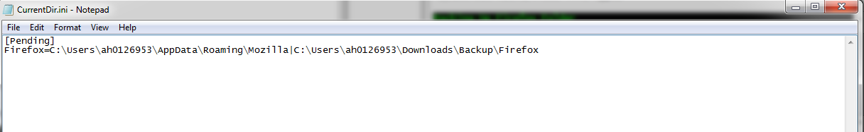

When I retry opening script after it showed failed

