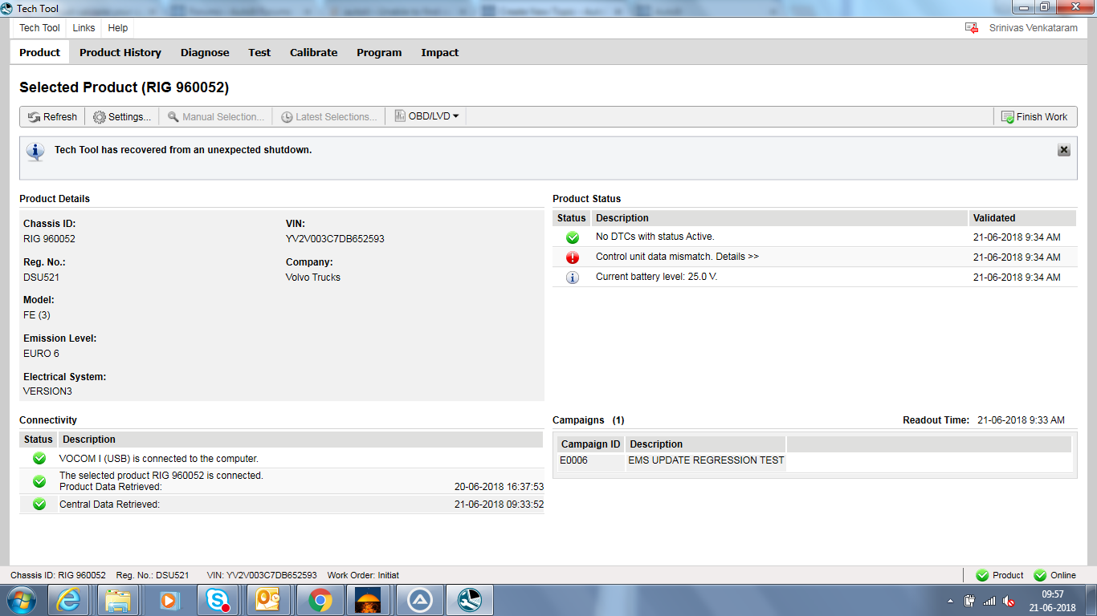
Screen shot of my application on which I need to perform automation. I need to click on Program tab and continue the next steps.

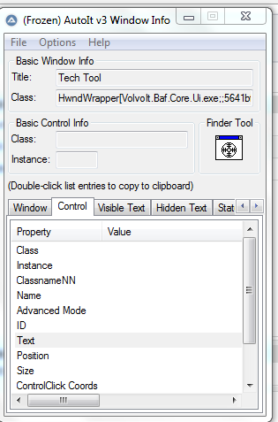
Screen shot of Window info which doesnot show anything.
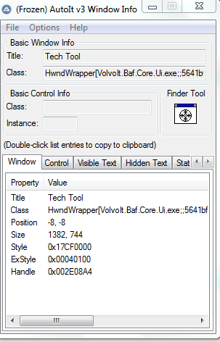
Only Basic info is shown.

