Start

Step 1)
Copy the A1 and paste it in the url Bar

Step 2)
Copy the Zip code from A2 and paste it into the embedded SFDC Web Part
This web page does not allow for selection of components using Window Info (so makes it hard to use _IE functions
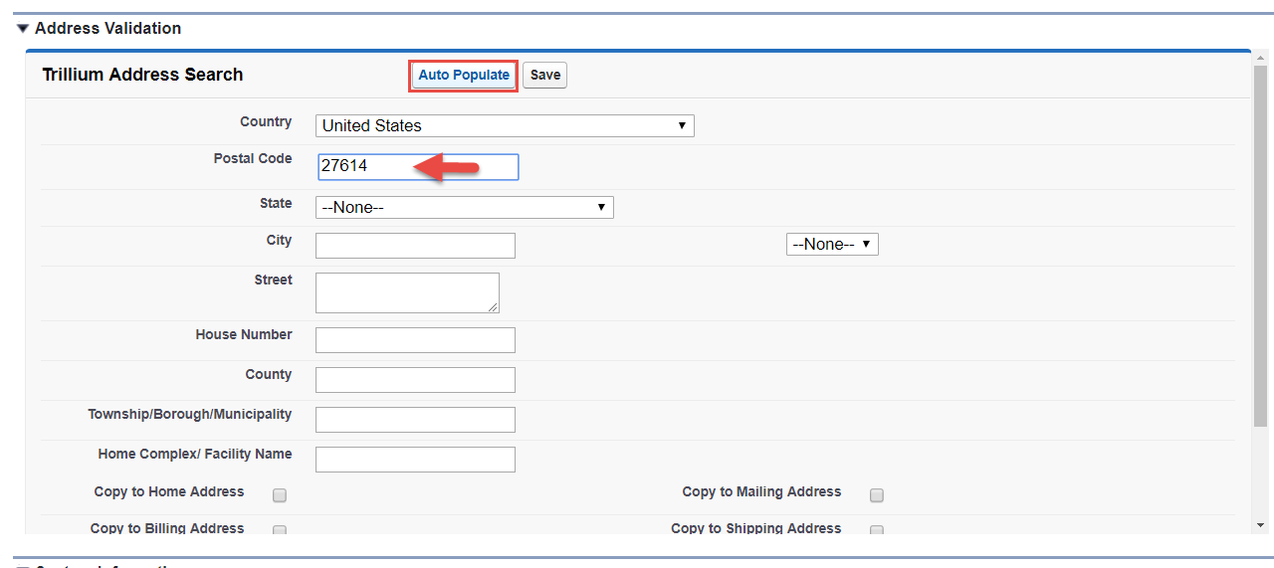
3) Select the Street Name from cell A3 and paste it into the Street section
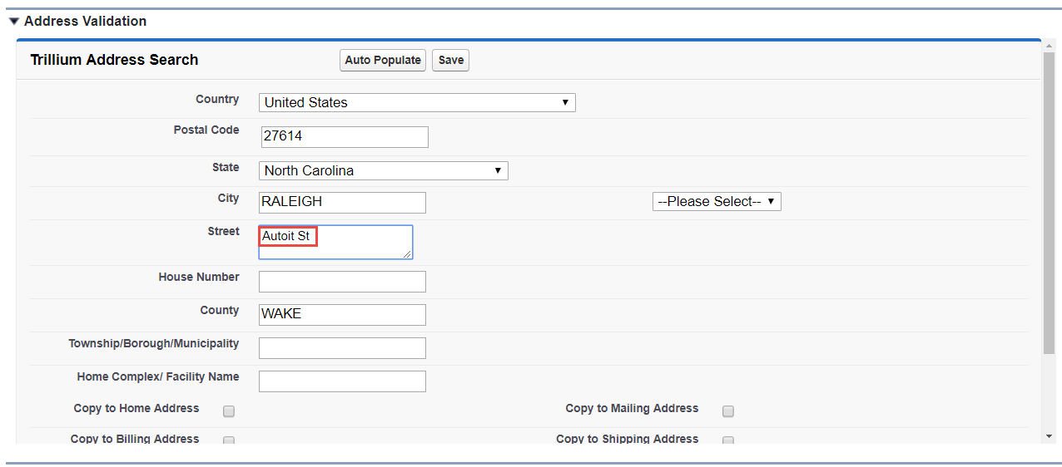
4) Select the House number from Cell A4 and paste it in the House Number field
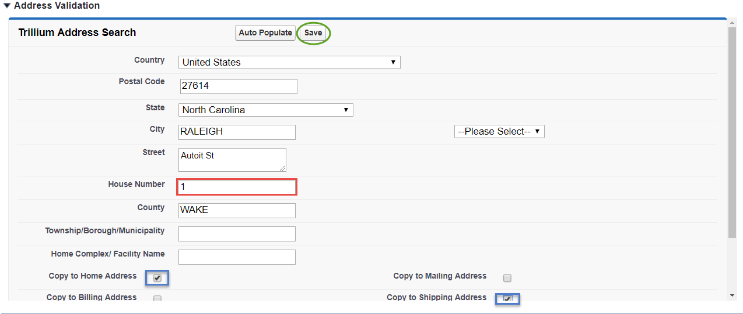
5) Check Copy to Home Address
6) Select Copy to Shipping Address
7) Click Save
REPEAT

