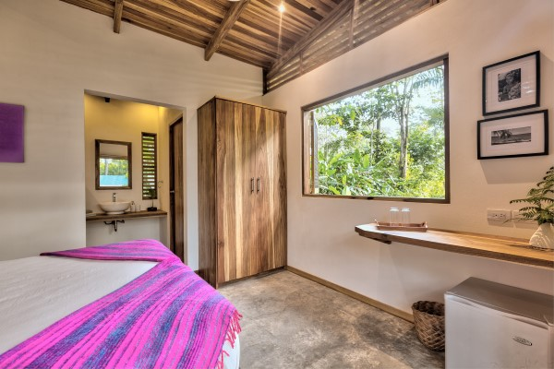
Mm

CHECK-IN CHECK-OUT
check in check out
Your Booking is
confirmed

1111111

