Original query – Highlighted row is the one that will be changed
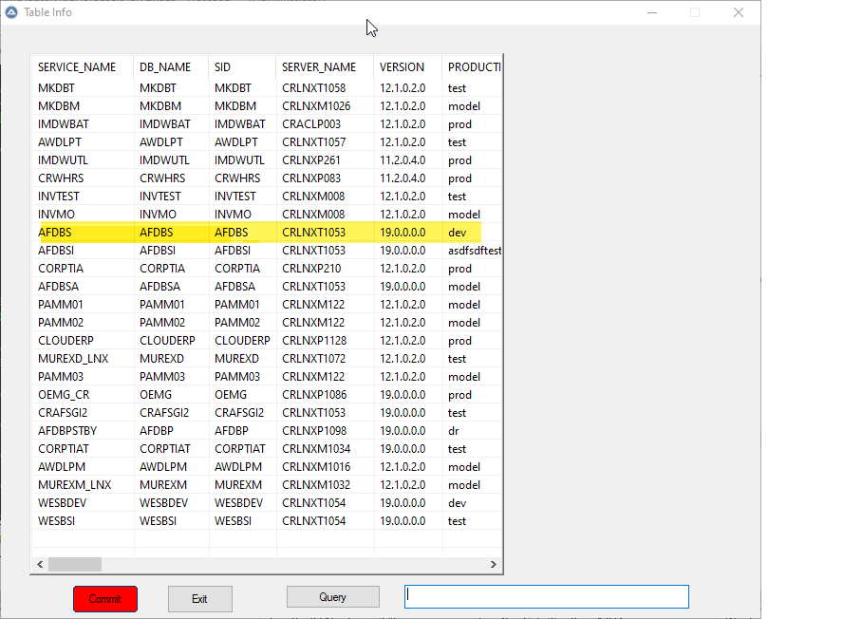

This shows a query on the listview and a change to the first field of the listview

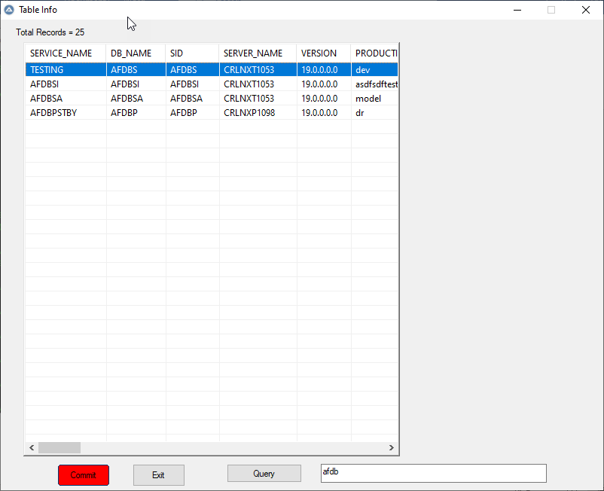

This shows all the rows in the listview again. The row is in the correct position.
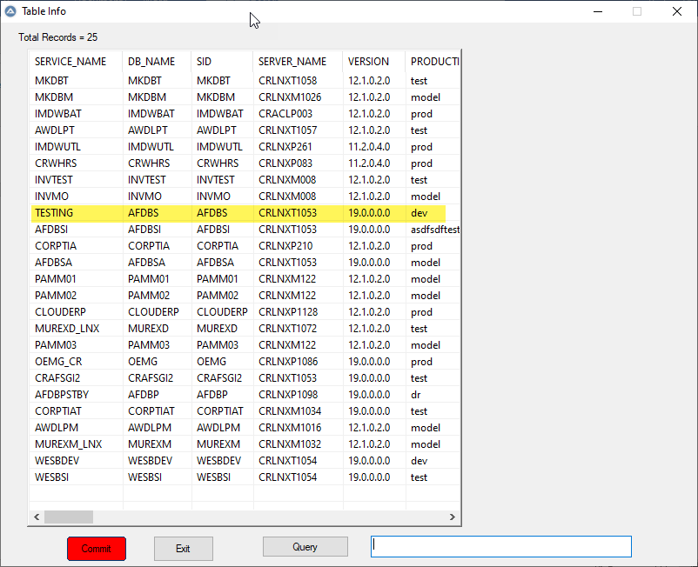

This is where I run into a problem. I run a sort on the 2nd column (DB_NAME) and the changed data does not follow. It should be shown in the 2nd row first colum. Instead it follows the $listview[0][1]

